International School

API Integration Plan Document
Course: System Integration Practices
Project Title: Integrated HR & Payroll Dashboard System for Company X
Case Study 2: Models Integration
Version: 1.0
Date: 20/03/2026
Group: Group 5
Semester: 2 – 2025–2026
Instructor: MSc. Nguyen Dang Quang Huy
Team Members:
Name | Student ID
Thong, Le Huu | 29219038101
Rin, Doan Ba | 29219037721
Tai, Su Phat Tai | 29211162809
Minh, Vo Van | 29219261748
Vinh, Nguyen Tran Xuan | 29211138585

Approved by
MSc Huy, Nguyen Dang Quang
Group Project - Instructor:

Name Signature Date

Da Nang 03/2026
Project Acronym | HRD
Project Title | Company X – Integrated HR & Payroll Management Dashboard
Start Date | 20 Mar 2026 | End Date | 21 Mar 2026
Lead Institution | International School, Duy Tan University
Role | Name | Email |  | Phone
Project Mentor | Nguyen Dang Quang Huy
 | Le Huu Thong | bass030196@gmail.com |  | 0768463655
 | Su Phat Tai | phattai0935@gmail.com |  | 0766657942
 | Nguyen Tran Xuan Vinh | xuanvinh2005nh@gmail.com |  | 0845015537
 | Vo Van Minh | vanminhvo2005@gmail.com |  | 0707944067
 | Doan Ba Rin | doanbarin@gmail.com |  | 0766721747

DOCUMENT NAME
Document Title | API Integration Plan Document
Reporting Period | 29– March - 2026
Author(s) | Le Huu Thong  Vo Van Minh  Su Phat Tai  Doan Ba Rin  Nguyen Tran Xuan Vinh
Role | Developer
Date | 21/03/2026 | File name | 5. API Integration Plan.docx

DOCUMENT APPROVALS
Document Approvals: The following signatures are required for approval of this document.

Mentor | Huy, Nguyen Dang Quang | Signature:
 |  | Date:
Team member(s) | Thong, Le Huu | Signature:
 |  | Date:
 | Tai, Su Phat | Signature:
 |  | Date:
 | Rin, Doan Ba | Signature:
 |  | Date:
 | Vinh, Nguyen Tran Xuan | Signature:
 |  | Date:
 | Minh, Vo Van | Signature:
 |  | Date:
TABLE OF CONTENTS
1. Introduction 6
1.1 Purpose 6
1.2 Scope 6
1.3 System Overview 7
2. Integration Objectives 7
3. Integration Architecture Overview 8
3.1 High-Level Architecture 8
3.2 Data Flow Diagram 9
4. API Design Plan 11
4.1 API Standards 11
4.2 API Endpoints 11
4.3 Sample API JSON Structures 13
4.4 Error Handling & Rollback Strategy 13
4.4.1 Error Classification 13
4.4.2 Error Handling Rules 14
4.4.3 Rollback Strategy 15
5. Data Mapping Reference 16
6. Security Considerations (Design Level) 21
7. Integration Testing Plan (Design Outline) 22
8. Deliverables and Next Steps 23
9. References 24

Introduction

1.1 Purpose
- The primary purpose of this document is to define a comprehensive API integration plan for the Integrated HR & Payroll Dashboard System, specifically focusing on the synchronization between the HUMAN_2025 (SQL Server) and PAYROLL (MySQL) databases. This plan is essential to automate data exchange, ensure real-time information sharing, and minimize manual data entry errors that often lead to discrepancies between HR records and financial payroll data. By establishing clear API standards, the project guarantees that employee profiles, department structures, and attendance logs remain consistent across both legacy platforms.
- It provides developers with detailed API specifications, data mapping logic, and security protocols—such as JWT authentication and Role-Based Access Control (RBAC)—required to build secure and functional endpoints. This integration plan ensures that the backend architecture effectively supports the visual analytics and smart alerting features required for Company X’s unified dashboard.

1.2 Scope
This document defines the integration boundaries and specific API activities required to connect the HR and Payroll systems. The scope includes:

- Data Synchronization: Automating the exchange of core data entities between HUMAN_2025 (SQL Server) and PAYROLL (MySQL), including employee profiles, department structures, position categories, and attendance logs.
- API Functional Operations: Developing RESTful API endpoints to support comprehensive system operations:
- CRUD Operations: Create, Read, Update, and Delete actions for employees, departments, and positions.
- Search & Filtering: Enabling advanced data retrieval based on employee name, month/year, or organizational unit.
- Reporting & Analytics: Providing aggregated data for visual dashboard reports, including salary trends and absenteeism rates.
- Out of Scope (In-scope for Planning Only): While advanced security protocols (such as multi-factor authentication or hardware-based encryption) are designed and documented at a planning level, full implementation of these high-level security features is excluded from this current phase.

1.3 System Overview
System | Database Type | Primary Tables | Role in Integration
HUMAN_2025 | SQL Server | Employee, Department, Position, Dividends. | Provides master data for human resources, organizational structure, and personnel profiles.
PAYROLL | MySQL | employees_payroll, salaries, attendance_data,  leave_requests. | Handles time-keeping records, automated salary calculations, and financial reporting based on HR data.

2. Integration Objectives
Objective | Description
Data Synchronization | Automatically synchronize employee and department information from HUMAN_2025 to PAYROLL to ensure data consistency.
API Connectivity | Design a standard RESTful API (JSON) system to connect the dashboard to the databases.
Extensibility | The architecture is flexible, allowing for the addition of new panels or modules without changing the existing structure.
Security & Authorization | Comprehensive security through JWT and user authorization (RBAC) across all API endpoints.
Real-time Analytics | Integrates data from across systems to display real-time payroll expense reports and attendance charts.

3. Integration Architecture Overview

3.1 High-Level Architecture
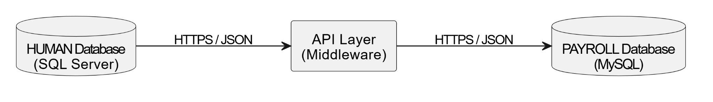
- Role of the API Layer (Middleware): It acts as the central intermediary integration layer between the two independent legacy databases. It is responsible for orchestrating the synchronization logic, validating data, authenticating user access, and seamlessly bridging the HUMAN and PAYROLL systems without requiring any structural modifications to the source databases.
- Data Exchange Format (JSON): All data transmitted between the systems and the API layer is formatted in JSON (JavaScript Object Notation). This ensures that the data structure remains lightweight, easily parsable, and highly compatible across the different environments (e.g., SQL Server, MySQL, and the React Dashboard).
- Communication via HTTPS: To guarantee the utmost security and integrity of sensitive HR and payroll records, all API communications are strictly encrypted and transmitted over the HTTPS protocol. This prevents unauthorized access and ensures secure data in transit.

Data Flow Diagram
3.2.1 The main components in DFD
Name component | Describe
HUMAN System | HUMAN System
API Integration Layer | API Integration Layer
PAYROLL System | PAYROLL System
Dashboard (React/…) | Dashboard (React)
3.2.2 Overview data flow diagram
Data Flow Description:
- The DASHBOARD (React) serves as the top-level user interface, responsible for receiving user actions (e.g., managing employees, viewing reports) and displaying integrated data such as Report Data and Alerts.
- The API INTEGRATION LAYER (Flask / .NET) acts as the central middleware, specifically processing synchronization logic, handling JWT security authentication, and performing strict data validation.
- The PAYROLL SYSTEM (MySQL) is the financial database that processes and stores business operations related to salary calculations, bonuses, deductions, and attendance records.
- The HUMAN SYSTEM (SQL Server) sits at the foundational level, functioning as the master data repository that contains core information regarding employee profiles, departments, and positions.
- Data Flow Direction: User requests travel downwards from the Dashboard through the API to the respective databases, while the actual data (HR, Payroll, Attendance) is extracted, aggregated by the API, and flows upwards to be presented to the user.
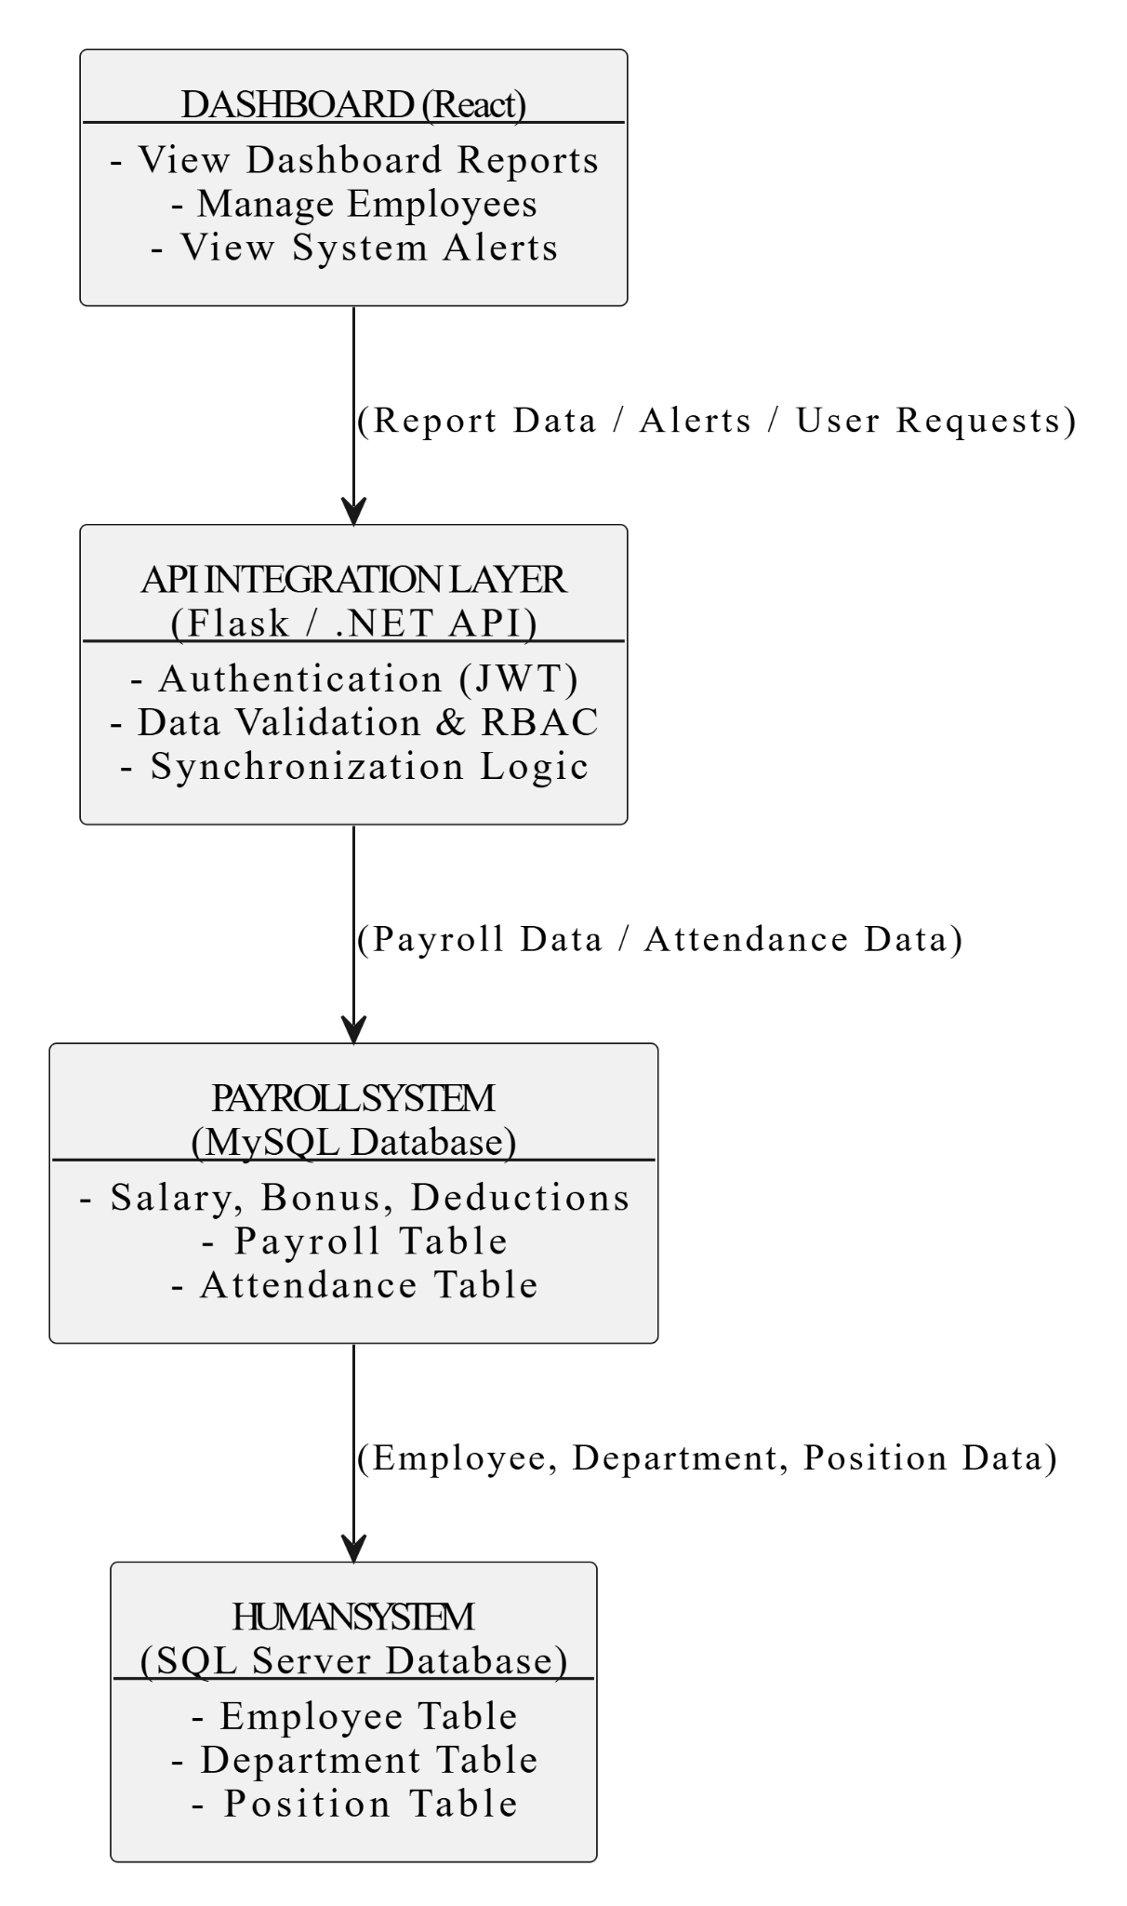

4. API Design Plan

4.1 API Standards
- Protocol: RESTful
- Data: JSON
- Authentication: Token / JWT.
- Status Codes:
  - 200: Success, data is taken.
  - 201: Created, new data was successfully added.
  - 400: Bad request, there is something wrong with data.
  - 404: Not found.
  - 500: Server Error.

4.2 API Endpoints
API ID | Endpoint Name | Method | Description | Data Flow
API-01 | /api/v1/auth/login | POST | Login | HUMAN → PAYROLL
API-02 | /api/v1/admin/users | POST | Manage Users and Roles | PAYROLL → HUMAN
API-03 | /api/v1/employees | GET | View Employee List | HUMAN → Dashboard
API-04 | /api/v1/employees | POST | Add New Employee | HUMAN → Dashboard
API-05 | /api/v1/employees/{id} | POST | Edit Employee Information | HUMAN → Dashboard
API-06 | /api/v1/employees/{id} | POST | Delete Employee | HUMAN → Dashboard
API-07 | /api/v1/departments | POST | Manage Departments | HUMAN → Dashboard
API-08 | /api/v1/positions | POST | Manage Positions | HUMAN → Dashboard
API-09 | /api/v1/salaries | GET | View Salary List | PAYROLL → Dashboard
API-10 | /api/v1/salaries/history/{id} | GET | View Salary History | PAYROLL → Dashboard
API-11 | /api/v1/attendance | GET | View Attendance Data | PAYROLL → Dashboard
API-12 | /api/v1/reports/dashboard | GET | View Dashboard Reports | HUMAN, PAYROLL → Dashboard
API-13 | /api/v1/system/alerts | GET | View System Alert | HUMAN, PAYROLL → Dashboard

4.3 Sample API JSON Structures
POST /employee/add
{
"EmployeeID": "E102",
"FullName": "Nguyen Van An",
"Salary": 12000000
}
- Response:
{“status": "success", "message": "Employee synchronized”}

4.4 Error Handling & Rollback Strategy

4.4.1 Error Classification
Error Type | Description | Example
Connection Error | API can’t connect to database | “500 - Timeout connecting to PAYROLL database.”
Authentication Error | JWT Token is expired, missing or invalid. | “401 – Unauthorized access.”
Data Validation Error | Data missing required fields or duplicated. | “400 - EmployeeID missing or duplicate.”
Internal Error | Login bugs or server-side crashes. | “500 – Internal Server Error.”
Conflict Error | Trying to add some ID that already exist | “400 - Employee is already exist”
Missing Resource | The requested employee does not exist. | “404 - Employee not found”

4.4.2 Error Handling Rules
Error Type | System Action | Response JSON
Missing Fields | Return 400 and notify the missing fields. | {“status": "failed", "message": "FullName is required”}
Invalid Token | Return 401 and request login again. | {“status": "failed", "message": "Unauthorized access”}
Sync Fail/ Database down | Write log in SYNC_LOG, make a Rollback | {“status": "failed", "message": "Rollback executed to maintain consistency”}
System Error | Write log and send error to admin | {“status": "error", "message": "Unexpected system error”}
Duplicate ID | Return 400 and stop the process, preventing creating duplicate records. | {“status": "error", "message": "Employee ID is already exist”}

4.4.3 Rollback Strategy
Step 1: Temporary Record
- When the API performs synchronization (e.g., adding a new employee), the data is temporarily stored in the SYNC_TEMP table..
- Only when both systems successfully update will this record be moved to the "Success" state.
Step 2: Error Detection and Rollback Trigger
- If the API receives an error from either system (e.g., PAYROLL returns the error "Duplicate Emp_Code"),
- The system will automatically delete the newly added data on the other side (if any), or mark the temporary record as "Failed".
Step 3: Error Logging
- All errors are recorded in the SYNC_LOG table with the following information: API name, error, time, and rollback status.
- If automatic rollback is not possible, the technical team will manually handle the issue based on the records in SYNC_LOG.
Objective:
- Ensure that there are no situations where data is only updated in one system.
- HUMAN and PAYROLL data remain consistent after each synchronization.

SYNC_TEMP Table
TempID | EmployeeID | ActionType | Status | CreatedAt
T1001 | E123 | Insert | Pending | 2025-10-21 10:22:11
T1002 | E124 | Insert | Failed | 2025-10-21 10:30:05

SYNC_LOG Table
LogID | APIName | ErrorMessage | RollbackFlag | CreatedAt | Resolved
L1001 | /api/v1/employees/sync | PAYROLL insert failed (duplicate ID) | 1 | 2025-10-21 10:31 | 0

5. Data Mapping Reference
Employee Entity
Entity | SQL Server | Datatype | PAYROLL (MySQL) | Datatype | Synchronous direction | Comment
Employee | EmployeeID | NVARCHAR (10) | Emp_Code | VARCHAR (10) | HUMAN → PAYROLL | Primary key
Employee | FullName | NVARCHAR (100) | Emp_Name | VARCHAR (100) | HUMAN → PAYROLL
Employee | Gender | NVARCHAR (10) | Gender | VARCHAR (10) | HUMAN → PAYROLL
Employee | DateOfBirth | DATE | DOB | DATE | HUMAN → PAYROLL
Employee | DepartmentID | INT | Dept_Code | VARCHAR (10) | HUMAN → PAYROLL
Employee | Position | NVARCHAR (50) | Position | VARCHAR (50) | HUMAN → PAYROLL
Employee | StartDate | DATE | JoinDate | DATE | HUMAN → PAYROLL
Employee | Status | NVARCHAR (10) | Emp_Status | VARCHAR (10) | HUMAN ↔ PAYROLL
Department Entity
Entity | SQL Server | Datatype | PAYROLL (MySQL) | Datatype | Synchronous direction | Comment
Department | DepartmentID | int | DepartmentID | int | HUMAN → PAYROLL | Primary key
Department | DepartmentName | NVARCHAR (100) | DepartmentName | VARCHAR (100) | HUMAN → PAYROLL
Department |  |  | SyncedAt | DATETIME | HUMAN → PAYROLL
Department | CreatedAt | DATETIME |  |  | HUMAN → PAYROLL
Department | UpdatedAt | DATETIME |  |  | HUMAN → PAYROLL
Position Entity
Entity | SQL Server | Datatype | PAYROLL (MySQL) | Datatype | Synchronous direction | Comment
Position | PositionID | int | PositionID | int | HUMAN → PAYROLL | Primary key
Position | PositionName | NVARCHAR (100) | PositionName | VARCHAR (100) | HUMAN → PAYROLL
Position |  |  | SyncedAt | DATETIME | HUMAN → PAYROLL
Position | CreatedAt | DATETIME |  |  | HUMAN → PAYROLL
Position | UpdatedAt | DATETIME |  |  | HUMAN → PAYROLL
Attendance Entity
Entity | SQL Server | Datatype | PAYROLL (MySQL) | Datatype | Synchronous direction | Comment
Attendance |  |  | AttendanceID | int | PAYROLL→ HUMAN | Primary key
Attendance |  |  | EmployeeID | int | PAYROLL→ HUMAN
Attendance |  |  | WorkDays | int | PAYROLL→ HUMAN
Attendance |  |  | AbsentDays | int | PAYROLL→ HUMAN
Attendance |  |  | LeaveDays | int | PAYROLL→ HUMAN
Attendance |  |  | AttendanceMonth | date | PAYROLL→ HUMAN
Attendance |  |  | CreatedAt | datetime | PAYROLL→ HUMAN
Salaries Entity
Entity | SQL Server | Datatype | PAYROLL (MySQL) | Datatype | Synchronous direction | Comment
Salary |  |  | SalaryID | int | PAYROLL→ HUMAN | Primary key
Salary |  |  | EmployeeID | date | PAYROLL→ HUMAN
Salary |  |  | SalaryMonth | decimal | PAYROLL→ HUMAN
Salary |  |  | BaseSalary | decimal | PAYROLL→ HUMAN
Salary |  |  | Bonus | decimal | PAYROLL→ HUMAN
Salary |  |  | Deductions | decimal | PAYROLL→ HUMAN
Salary |  |  | NetSalary | decimal | PAYROLL→ HUMAN
Salary |  |  | CreatedAt | datetime

Dividends Entity
Entity | SQL Server | Datatype | PAYROLL (MySQL) | Datatype | Synchronous direction | Comment
Dividend | DividendID | int |  |  | HUMAN → PAYROLL | Primary key
Dividend | EmployeeID | int |  |  | HUMAN → PAYROLL
Dividend | DividendAmount | decimal |  |  | HUMAN → PAYROLL
Dividend | DividendDate | date |  |  | HUMAN → PAYROLL
Dividend | CreatedAt | datetime |  |  | HUMAN → PAYROLL

6. Security Considerations (Design Level)
At the design level, the API Integration Layer acts as an intermediary bridge transmitting sensitive data between the HUMAN System and the PAYROLL System. To ensure information security, the system will apply 3 core security mechanisms:
- Secure Communication (HTTPS Protocol): All data exchanged between the Dashboard (React), the API Middleware layer, and the databases is encrypted and transmitted over the HTTPS protocol. This helps protect data integrity and prevents data interception attacks on the transmission line (Man-in-the-Middle).
- User Authentication (Authentication via JWT): It is expected that in the implementation phase (Case 3), the system will use the JSON Web Token (JWT) standard to authenticate and manage user sessions. Upon successful login, a token will be issued. Any request sent to the API must include a valid JWT in the Header (as a Bearer Token) for the system to verify the caller's identity.
- Role-Based Access Control (RBAC): The system will check the permissions (Role) encoded within the JWT to decide whether to allow or deny the execution of API Endpoints. The access control structure is divided into 3 main roles:
  - Admin: System administrator, with full access to all APIs, including user management and viewing system logs.
  - HR (Human Resources): Only has access to APIs managing human resources information (Add/Update/Delete Employee, Department, Position).
  - Payroll: Only has access to finance-related APIs (Payroll synchronization, salary calculation, attendance).

7. Integration Testing Plan (Design Outline)
Test ID | API Endpoint | Objective | Expected Result
T01 | POST /employees | Add Employee Sync: Test inserting a new employee and verify bidirectional synchronization. | Returns “201 Created” The new employee record successfully appears in both HUMAN_2025 (SQL Server) and PAYROLL (MySQL) databases.
T02 | POST /employees | Duplicate Validation: Attempt to insert an employee with a duplicated EmployeeID. | Returns “409 Conflict” The transaction is aborted, and data is not inserted into either database.
T03 | DELETE /employees/id | Constraint Validation: Attempt to delete an employee who already has salary records in the PAYROLL.salaries table. | Returns “409 Conflict” or an error status. The deletion is strictly blocked by the API layer to maintain data integrity.
T04 | PUT /departments/id | Update & Sync: Update an existing department's information and verify the synchronization. | Returns “200 Success”. Changes are successfully synced from HR to PAYROLL.
T05 | GET /payroll | Data Retrieval: Test the accuracy of payroll data retrieval. | Returns “200 Success”. The response contains accurate salary records directly fetched from PAYROLL.Salaries.
TP6 | GET /alerts | Alerts Correctness: Generate system alerts (e.g., work anniversaries, excessive leave, salary anomalies). | Returns “200 Success”. The JSON response correctly identifies and aggregates anomalies from both HR and Payroll databases.

8. Deliverables and Next Steps
8.1 Case Study 2 Deliverables
This document is part of the comprehensive design phase for integrating the HUMAN_2025 and PAYROLL systems. The complete set of deliverables for this phase includes:
- SRS (Software Requirements Specification) V1: Details the functional requirements derived from the CEO Memo and Case Study 1.
- Integration Architecture Document: Contains the system architecture diagrams, data flow, synchronization logic, and error-handling workflows.
- Data Mapping Document: Provides the full field-to-field mapping between the SQL Server (HR) and MySQL (Payroll) databases.
- API Integration Plan Document: This current document, outlining the RESTful API endpoints, request/response structures, and error classification.
- UI/UX Design Document: Static mockups for the Dashboard, Employee Management, Payroll, and Alerts interfaces.
- Updated Project Plan: Task tracking for weeks 3-4.
8.2 Next Steps (Transition to Case Study 3)
The next case (Case Study 3) will implement and test the APIs defined here. The development phase will focus on:
- API Development: Implementing the backend using C# (.NET 8 Web API) or Python (Flask/FastAPI) to connect simultaneously to SQL Server and MySQL.
- Synchronization Logic & Transactions: Developing the cross-database synchronization logic with strict commit/rollback transaction handling to ensure data consistency.
- Testing: Executing Unit Testing (xUnit/NUnit or pytest/unittest) and API Testing (using Postman/Swagger) based on the test plan outlined in section 7.
- Future Documentation: Producing the next sequence of documents, including Document 6 (API Implementation Document), Document 7 (Test Plan), Document 8 (Test Case Document), Document 9 (Updated SRS v2), and Document 10 (Updated Data Mapping Document).

9. References
  - Case Study 2 document.
  - Swagger RESTful API documentation.
  - Microsoft SQL Server & MySQL Docs.
  - C# (.NET 8 Web API) / Python (Flask or FastAPI) Documentation.
  - Postman / Insomnia Documentation.
  - API & Testing Framework Documentation.

